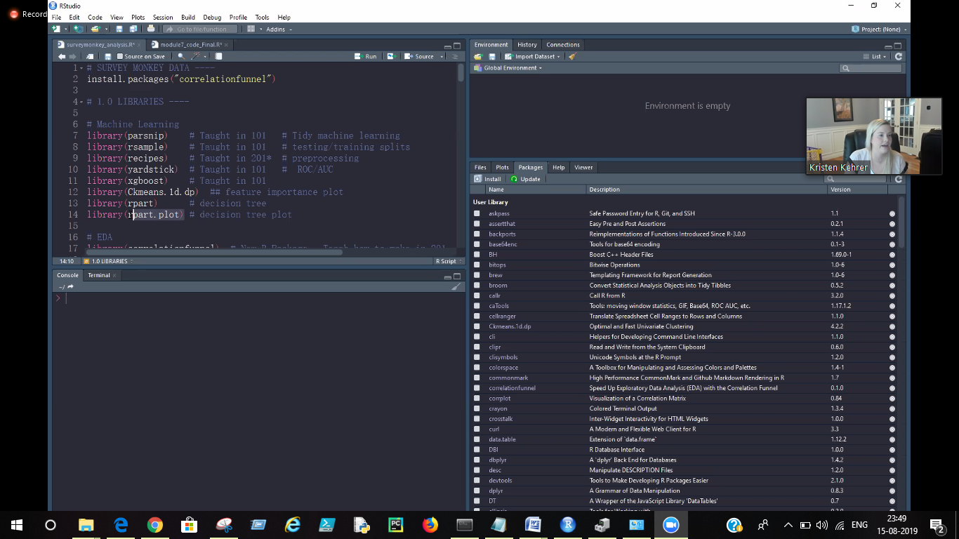

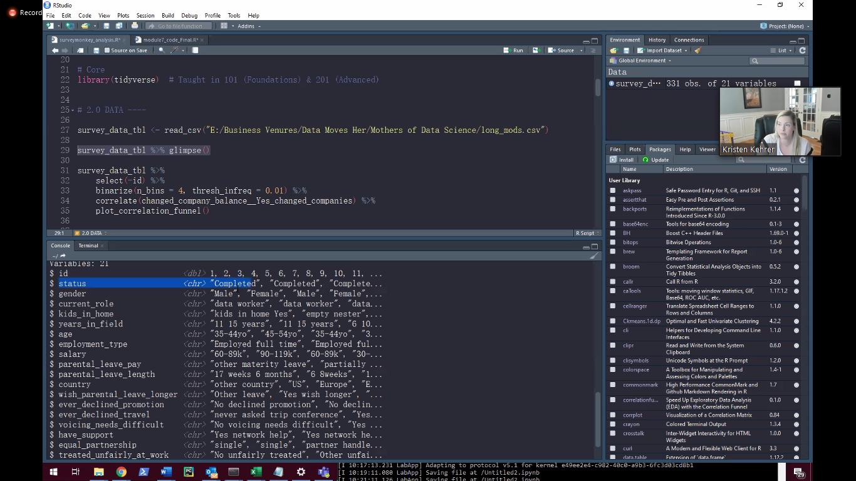

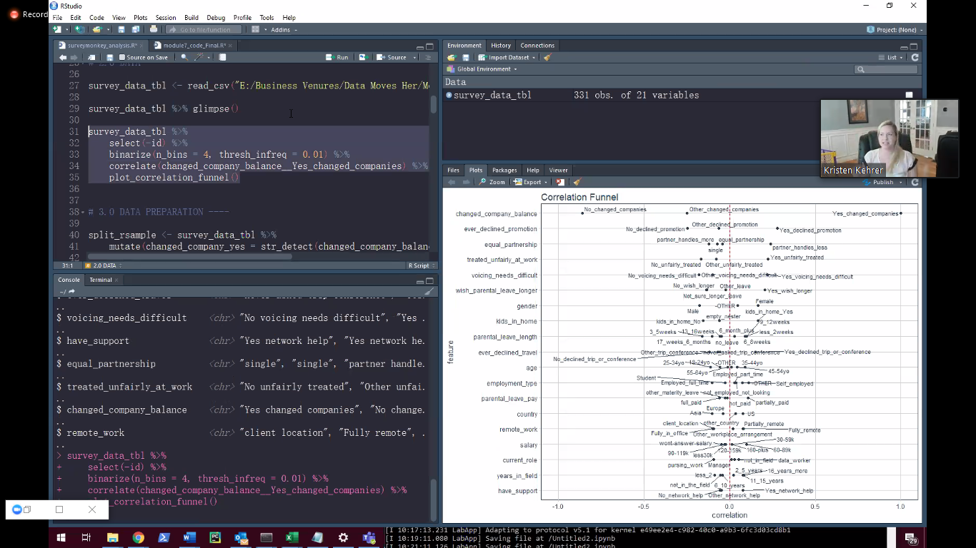

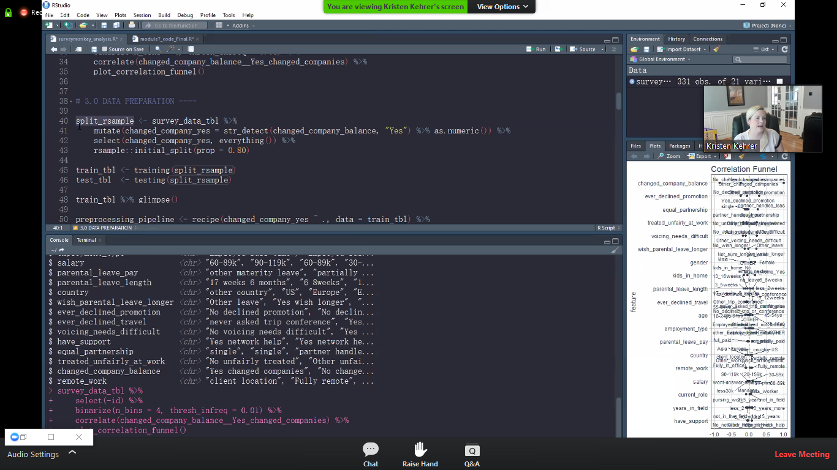

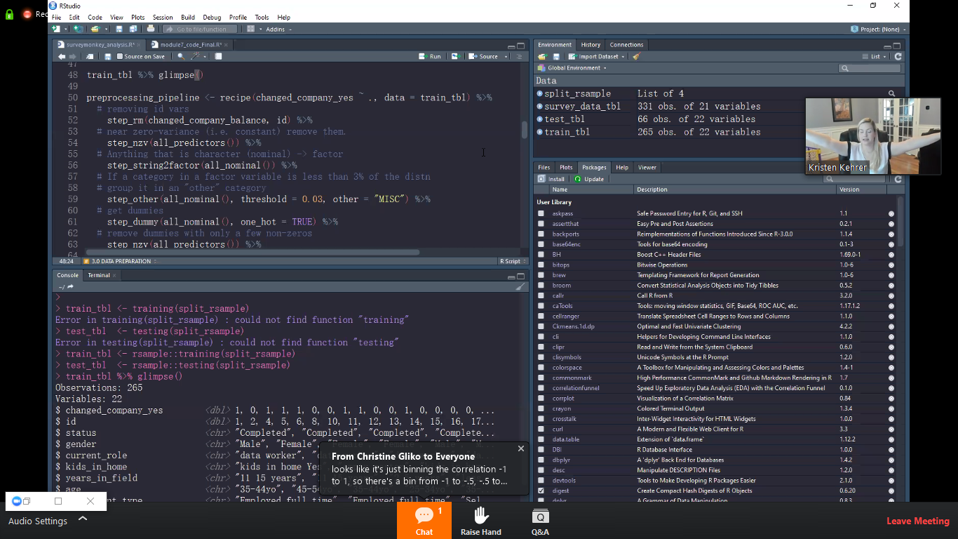

Anonymous Attendee 11:33 PM

Can hyperameter tuning (random grid, grid search) with parsnip please be covered. I’m yet to see any concrete examples of this.

Matt Dancho 11:54 PM

Hi, this is being built. The dials package is where this is going to be handled, but parsnip is so new that RStudio is rebuilding dials to make Cross Validation super easy.

Dan McNulty 11:38 PM

Will this powerpoint be available to download? Wondering if I should take detailed notes :P

Matt Dancho 11:54 PM

THis is Matt - I will give the Slides to Kristen.

Morteza Moghaddam 11:52 PM

Do you use the correlationfunnel before imputaing or after?

Matt Dancho 11:55 PM

Hi Morteza,

Missing values (NAs) need to be handled before running the correlation funnel. Imputation is one strategy to use to handle the NAs. Definitely do this before.

Morteza Moghaddam 11:57 PM

Thx!, another question I have is if I have integers, does it make sense to convert those to numeric values and then use correlationfunnel

This question has been answered live

Morteza Moghaddam 11:58 PM

How would u decide on the n-bins and thresh_infreq?

Matt Dancho 12:06 AM

You would set n_bins to 4 or 5. Too low and you may miss nonlinearities. Too high and you get too much noise.

Praval Godre 12:00 AM

Generally How much correlation between variables is acceptable for a model?

This question has been answered live

Stephen Johnston 12:04 AM

Is there a limitation on this package for differences between character vectors versus numeric? Dummy coding?

Matt Dancho 12:07 AM

The limitation is correlation funnel only works with numeric and categorical data.

Morteza Moghaddam 12:05 AM

So, by doing this, no need to do EDA that much???How confident should we not doing the EDA?

Matt Dancho 12:10 AM

It speeds up EDA & helps us be more productive. You can still do more EDA, but it helps get to the core of the data quickly. We can then explore the top features (focus on them), we can reduce emphasis on the lower features. It helps us be more productive.

Adim Kris 12:07 AM

Is there a rule of thumb or standard threshold for correlation between variables that?

Anonymous Attendee 12:07 AM

Yes! Great question, how much of an impact would converting integers to numeric have?

Matt Dancho 12:13 AM

None. If there are few unique values, binarize() automatically converts to discrete. If many unique values, binarize() bins.

Asim Timalsina 12:13 AM

Will you drop one of the features after you one hot encode? For example for gender, will you drop the Male feature or female feature as they are highly correlated.

Matt Dancho 12:15 AM

Nope, not in machine learning. The machine learning algorithms (tree based) or penalized regression will automatically take care of highly correlated features.

Stephen Banick 12:15 AM

don’t the apply funcitons take out a lot of the neccessity for loops?

Matt Dancho 12:19 AM

I actually prefer purrr map() over apply functions. purrr is an 80/20 package (CRITICAL)

Jens Vester Christiansson 12:16 AM

I am fairly new to ML. How do you know to run a classification model?

Matt Dancho 12:18 AM

You will see. There is a predict() function to predict on new data.

Ajinkya Rane 12:17 AM

What is good? Sampling before preprocessing or after preprocessing?

This question has been answered live

Richard Pilbery 12:17 AM

Can you recruit a GPU when using xgboost in R?

Matt Dancho 12:18 AM

I believe you can as long as you have access to a GPU.

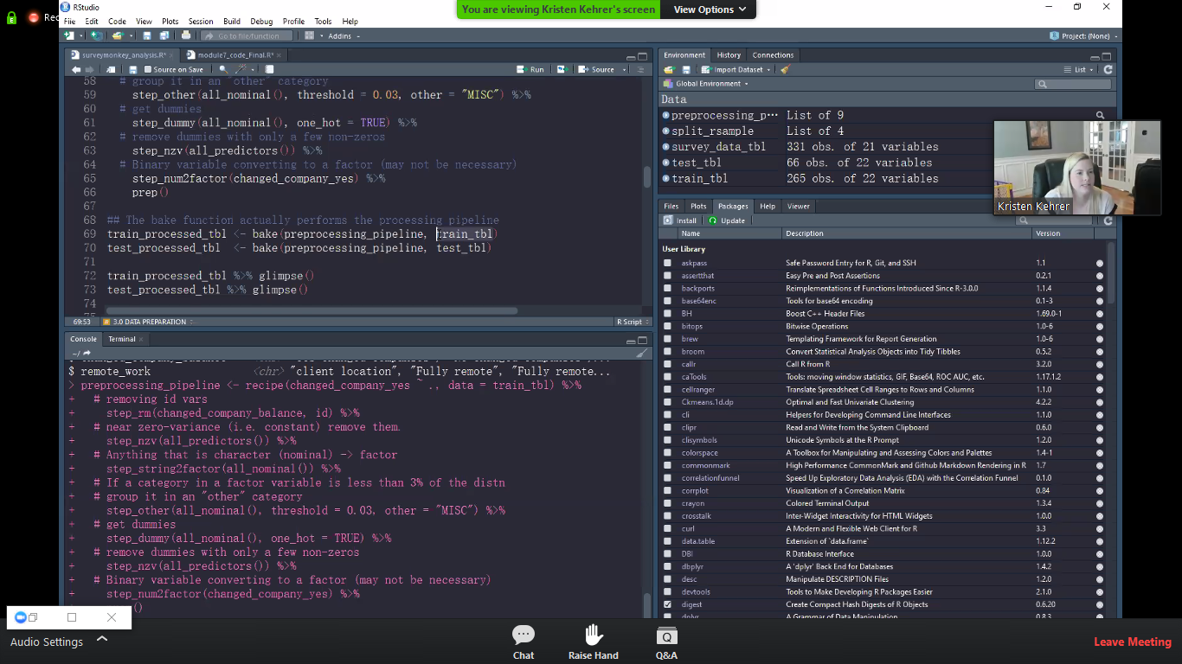

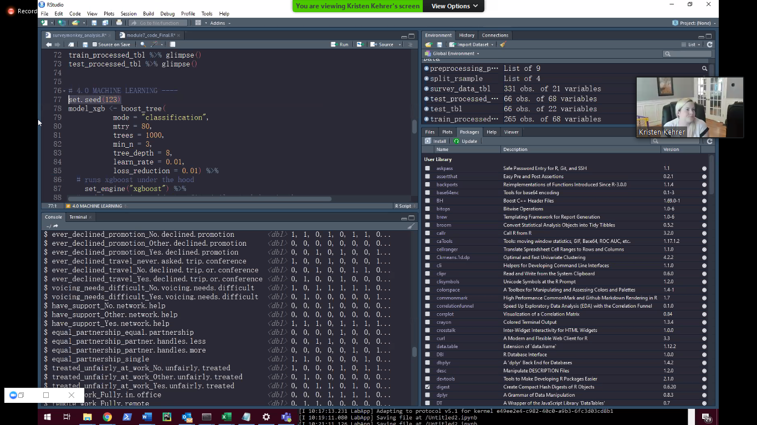

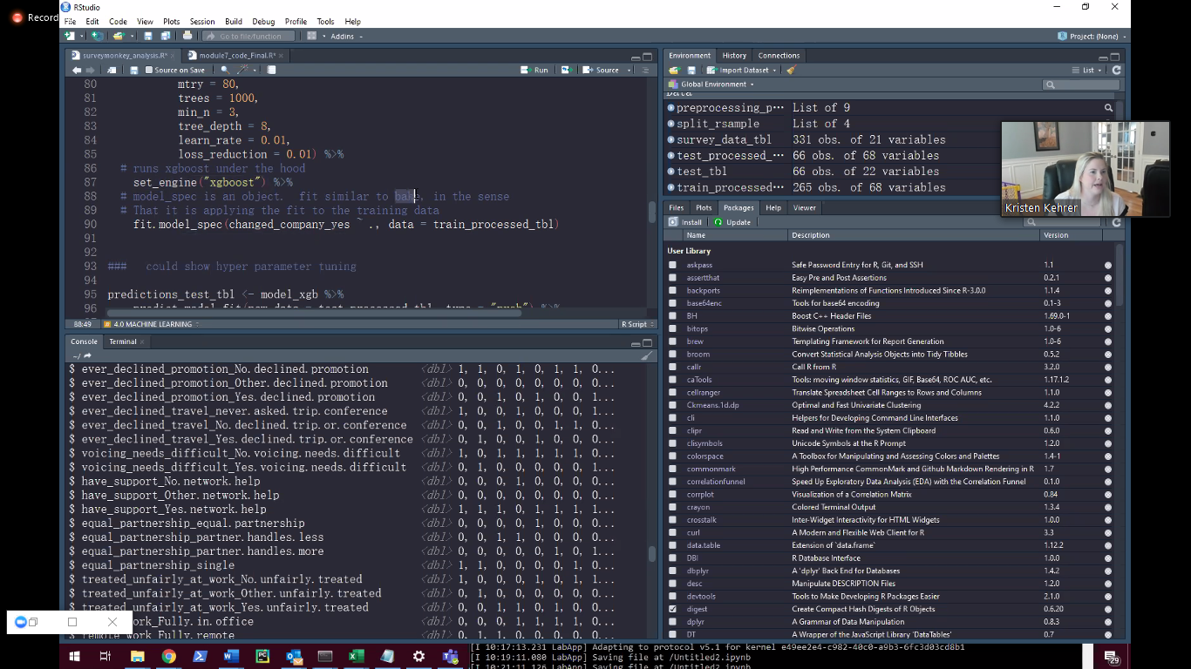

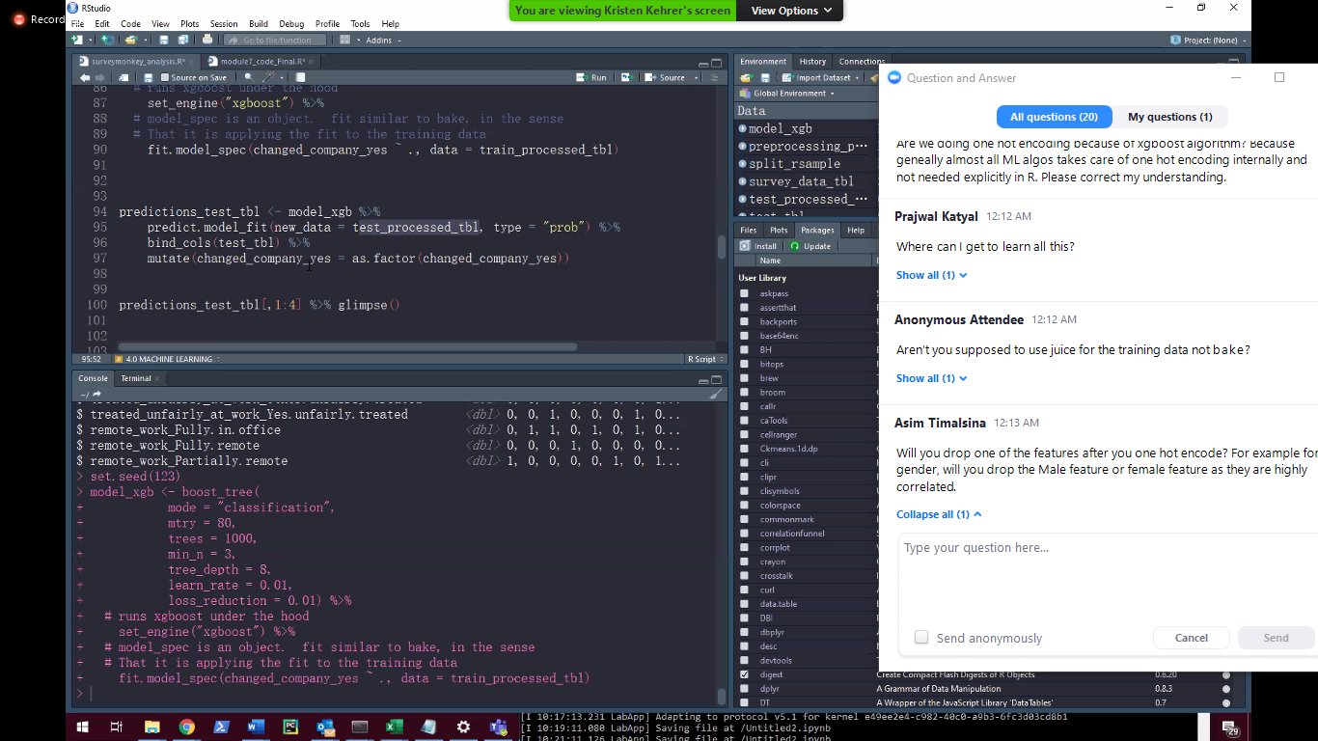

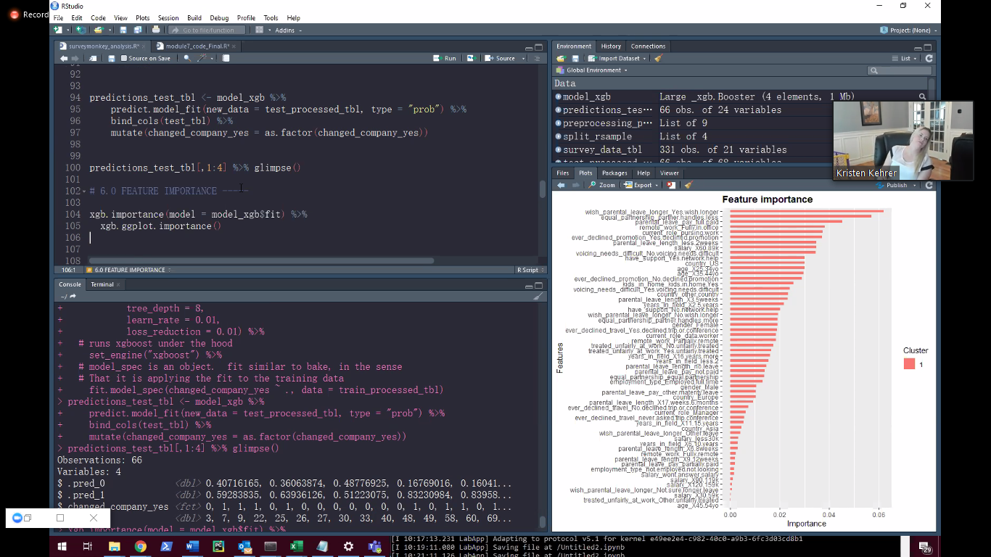

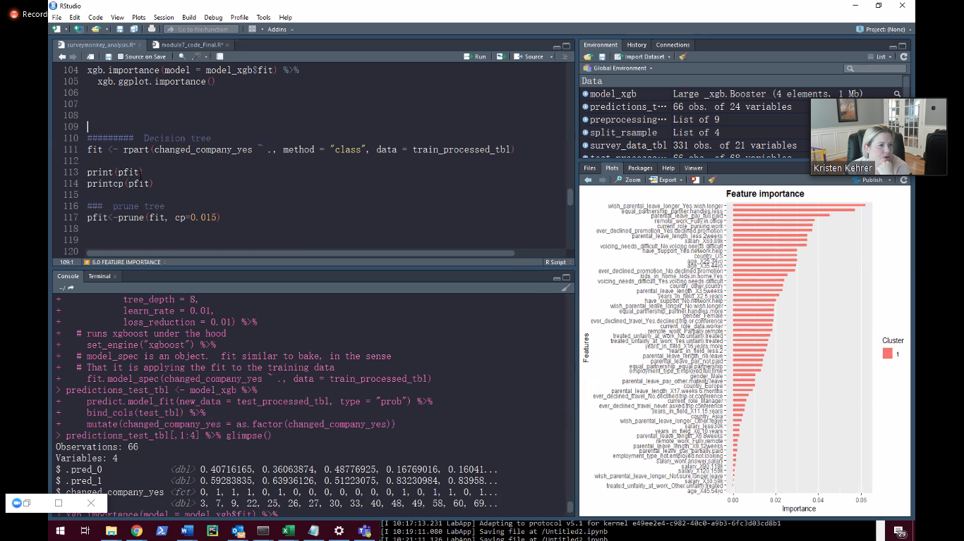

Asim Timalsina 12:18 AM

Sure, but it doesn’t hurt especially if we want to get into feature importances correct?

Matt Dancho 12:22 AM

You are right, Asim. It’s a great idea to explore the Feature Importances.

Anonymous Attendee 12:18 AM

Can recipes preprocessin be parralelized?

Matt Dancho 12:20 AM

Yes with the furrr package.

Aadith Kumar 12:23 AM

In your experience, which Algorithm takes less time to train, when parallelization is active - XGBOOST or RandomForest?

Matt Dancho 12:24 AM

Both are fairly fast. XGBoost is probably faster. It’s also very accurate, which is why it wins most Kaggle competitions.

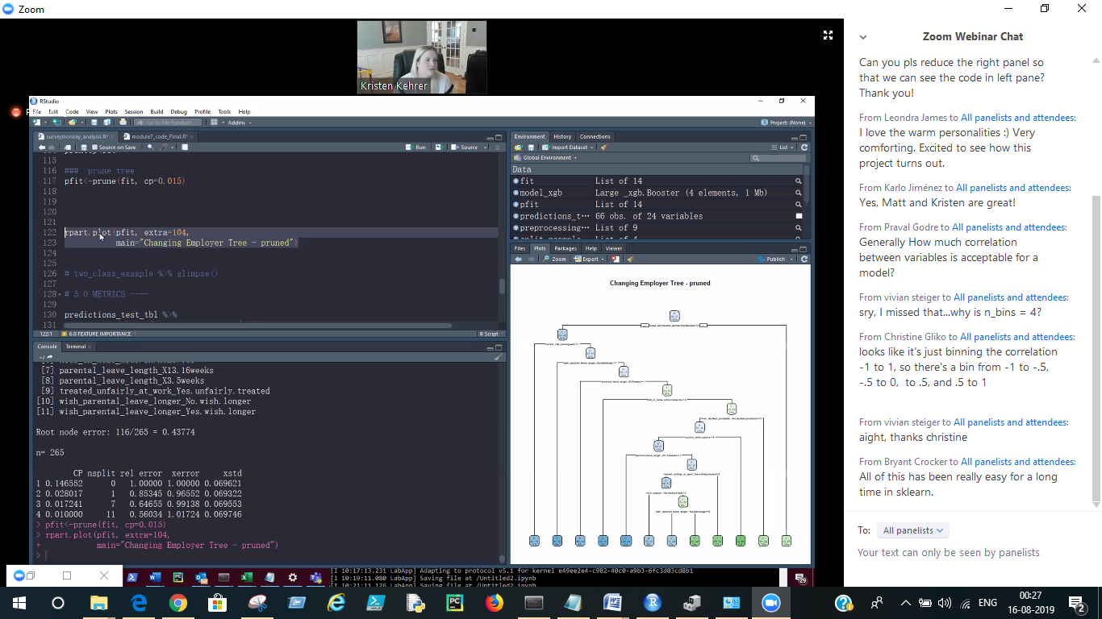

Amarjeet Sahoo 12:24 AM

Is this code is by Parsnip, because it's look very similar to the normal rpart and xgboost library

Matt Dancho 12:25 AM

The rpart code is rpart not parsnip. You are right. The xgboost as done in parsnip, which has the common API for modeling across packages.

Morteza Moghaddam 12:25 AM

Have you done in comparisons like using correlationfunnel vs not using it for feature engineering and see how much improves the model accuracy?

Matt Dancho 12:27 AM

Not sure I follow here - Correlation Funnel is mainly for EDA (understanding data). Feature engineering is a separate step once we are ready to move into modeling we still need to do Feature Engineering.

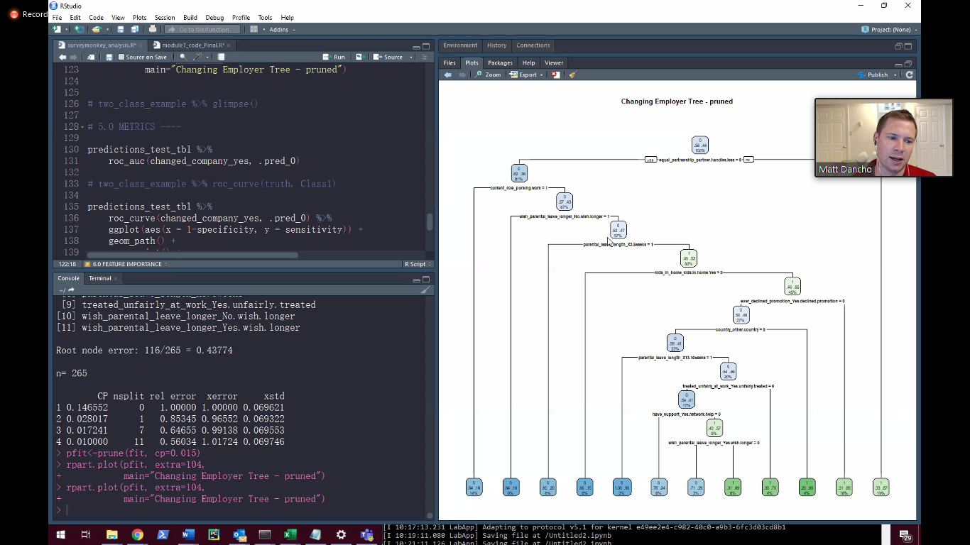

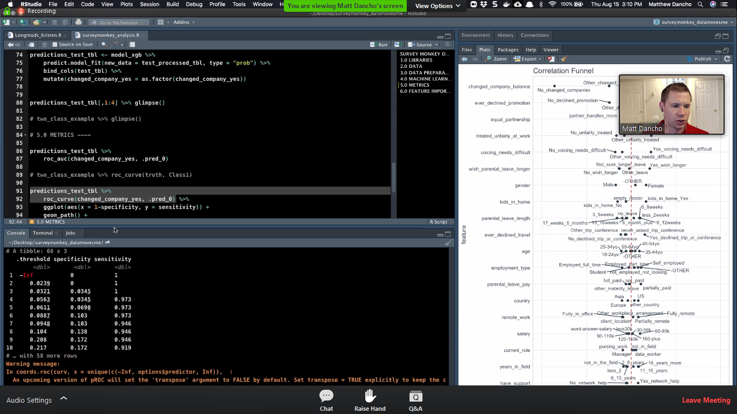

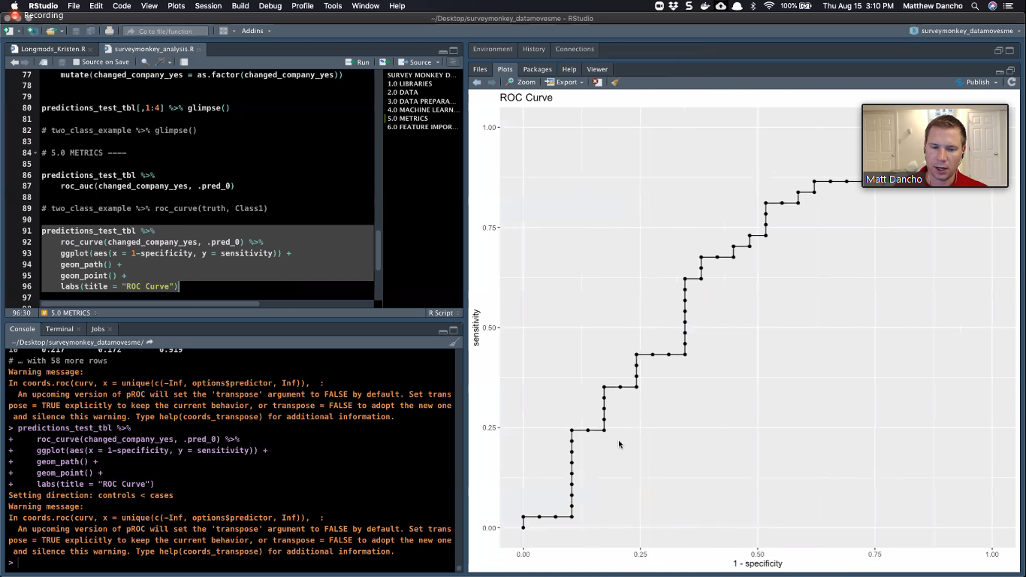

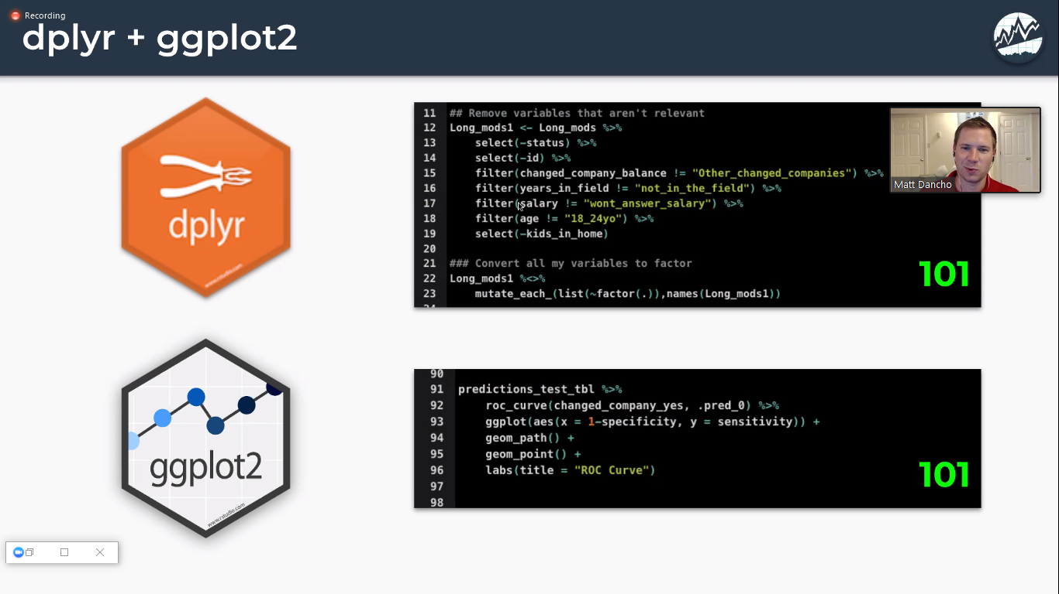

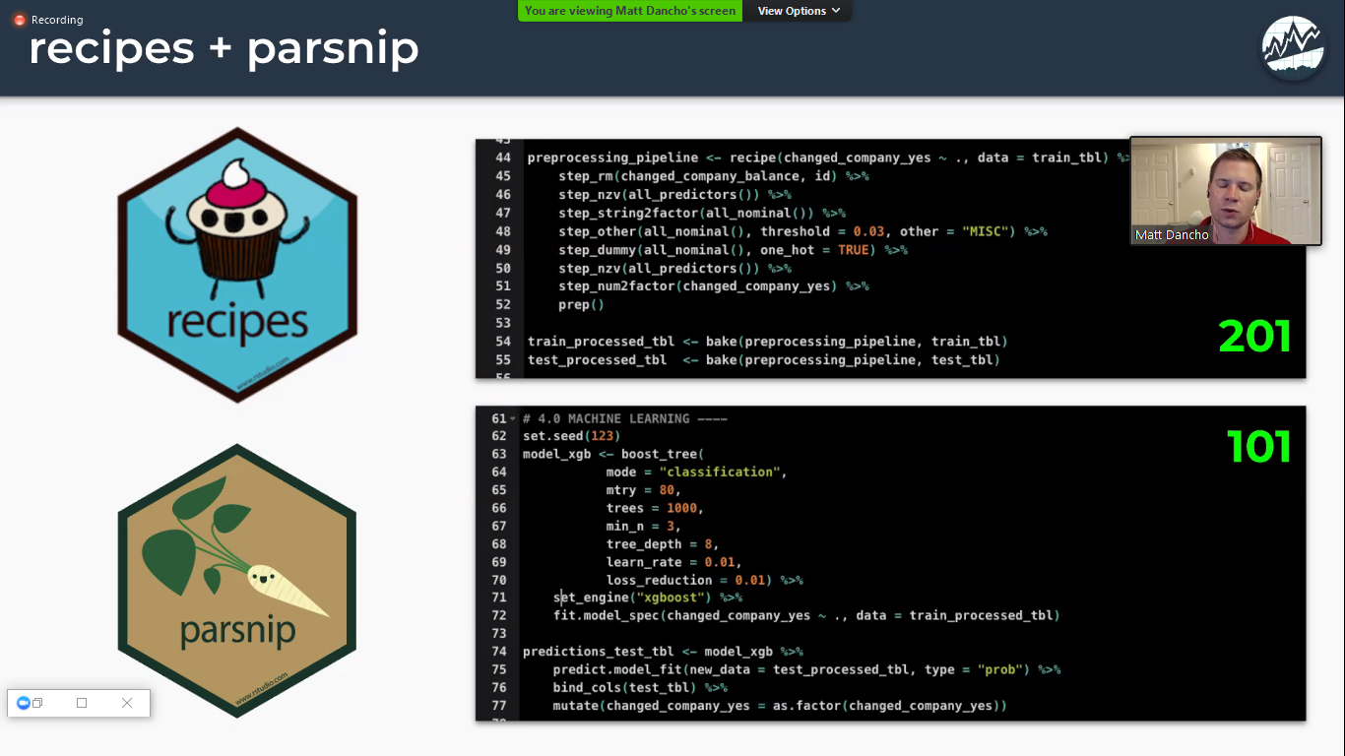

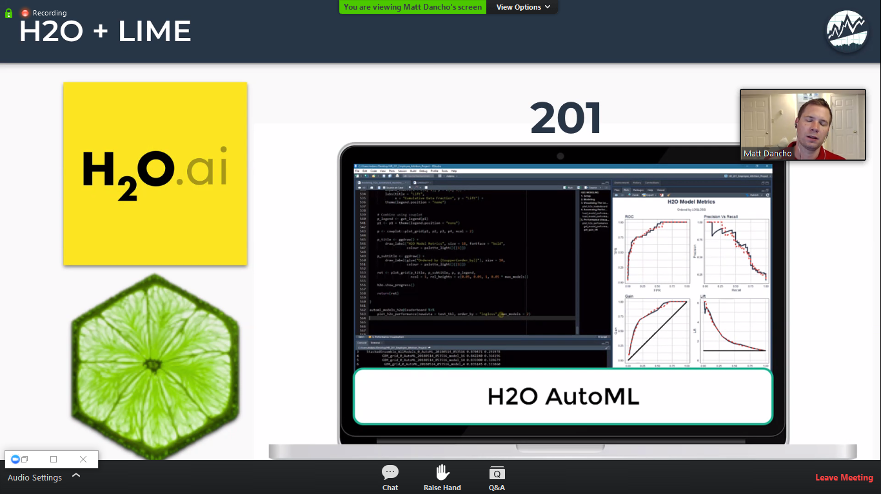

Jens Vester Christiansson 12:30 AM

What underlying assumptions/biases would you need to take into account, when you present a specific variable as the most important parameter for change? I know it is a big question.

Kristen Kehrer 12:46 AM

It's nice to try a couple different models and make sure that the story is the same across multiple models. And you're able to speak to the statistic you're using. If you're building a CHAID decision tree (for example) you'd say that it was the most statistically significant factor using a chi-square test statistic.

Richard Pilbery 12:33 AM

Can you customise the labels for these decision trees?

Kristen Kehrer 12:47 AM

Yes, and if I was going to present this to stakeholders I certainly would have cleaned this up. It may even be that I change the names of the variables that are most important to just have intuitive names and this would fix that problem.

Ananda Kiran Doppalapudi 12:38 AM

when will you use ROC/AUC curve verses Precision/Recall Curve ?

Kristen Kehrer 12:49 AM

It depends on what you're trying to say and who your audience is. ROC is a great plot for saying "hey, an ROC of .65 means that we're a little better than a coin flip".. so you may use multiple metrics and present them in real terms to help explain how your model is categorizing predictions.

Amarjeet Sahoo 12:42 AM

The ROC curve seems stepwise kind of (not a line), is it because of the survey data ?

Kristen Kehrer 12:49 AM

It's not supposed to be a straight line, it's a curve. Specifically ROC stands for receiving operator curve and AUC stands for area under curve.

You 12:12 AM

Are we doing one hot encoding because of xgboost algorithm? Because geneally almost all ML algos takes care of one hot encoding internally and not needed explicitly in R. Please correct my understanding.

Matt Dancho 12:21 AM

You are right that xgboost will take care of this internally. We explicitly do it, which is OK also.